

**T.C.**

**YILDIZ TEKNİK ÜNİVERSİTESİ / YILDIZ TECHNICAL UNIVERSITY**

**ENDÜSTRİ MÜHENDİSLİĞİ BÖLÜMÜ**

**STAJ DEFTERİ /**

**DEPARTMENT OF INDUSTRIAL ENGINEERING INTERNSHIP REPORT BOOK**

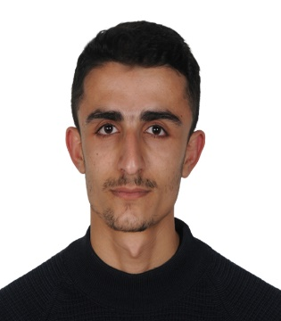STAJ TÜRÜ / INTERNSHIP TYPE:

FOTOĞRAF / PHOTOGRAPH

Dijital ortamdan eklenecektir. / It will be added digitally.

Atölye/Workshop Mesleki Alan-1/ Technical-1 Mesleki Alan-2/ Technical-2

ADI VE SOYADI / NAME AND SURNAME: Muhammed DİLBER

ÜNİVERSİTE NO / STUDENT NUMBER: 20069035

|  |  |  |  |  |
| --- | --- | --- | --- | --- |
| Kurumun Adı/Name of Institution | Bölüm / Department | Çalışma Süresi / Working Time | | Hafta/Week |
| Tarihinden/From | Tarihine/To |
| ROKETSAN, Rocket Industry and Trade Inc. | Network and System Support |  |  |  |
|  |  |  |  |  |
|  |  |  |  |  |
|  |  |  |  |  |
|  |  |  |  |  |
|  |  |  |  |  |
|  |  |  |  |  |
|  |  |  |  |  |
|  |  |  |  |  |
|  |  |  |  |  |

|  |  |  |  |  |
| --- | --- | --- | --- | --- |
| HAFTALIK ÇALIŞMA / WEEKLY WORK 01/08/2024 02/08/2024 arası / between | | | | |
| Gün / Day | YAPILAN İŞLER / ASSIGNED WORKS | Sayfa No / Page Number | | Çalışılan Saat / Hours Worked |
| Perşembe / Thursday | General information about Roketsan was given. Entrance cards were distributed and I met the mentor and the unit. |  | | 9 Hours(one hour break) |
| Cuma /  Friday | I received occupational health and safety training and information security training. |  | | 9 Hours(one hour break) |
| Bölüm / Section : | Information Technologies Infrastructure Unit | | Toplam Saat / Total Hours: | 18 Hours |
| Çalıştığı işyeri ve kısım / Workplace and section: Information Technologies Infrastructure Unit  Kontrol edenin unvanı / Controller's title: Senior lead engineer  Adı ve soyadı / Name and surname: Çakır Vural  Diploma veya oda sicil no / Diploma or chamber registration number: ………………………………………… | | | | |

|  |  |  |  |  |
| --- | --- | --- | --- | --- |
| HAFTALIK ÇALIŞMA / WEEKLY WORK 05/08/2024 09/08/2024 arası / between | | | | |
| Gün / Day | YAPILAN İŞLER / ASSIGNED WORKS | Sayfa No / Page Number | | Çalışılan Saat / Hours Worked |
| Pazartesi / Monday | I received my project (It is forbidden to bring or take electrical devices in Roketsan, but certain authorized persons are exempt. Therefore, I was asked to identify electrical devices such as laptops and tablets passing through X-ray devices). |  | | 9 Hours(one hour break) |
| Salı /  Tuesday | I started the most important step of my project, data collection. At first, I found the data on the internet. In order to apply this project, which is generally used to detect cutting devices for security, to electrical components, I combined the components in the data that were useful to me and created data. |  | | 9 Hours(one hour break) |
| Çarşamba / Wednesday | From the data I found over ten thousand, I started to find and label the ones with electrical components. I also started to do research for the models I would use. |  | | 9 Hours(one hour break) |
| Perşembe / Thursday | I started special studies on the image processing algorithms yolov5, yolov8 and yolov9. I started testing on a small dataset to find the most suitable model for my project. |  | | 9 Hours(one hour break) |
| Cuma /  Friday | I continued testing to see what values I should use for image size, epochs and batch as well as the model I would use. |  | | 9 Hours(one hour break) |
| Bölüm / Section: | Information Technologies Infrastructure Unit | | Toplam Saat / Total Hours: | 45 |
| Çalıştığı işyeri ve kısım / Workplace and section: Information Technologies Infrastructure Unit  Kontrol edenin unvanı / Controller's title: Senior lead engineer  Adı ve soyadı / Name and surname: Çakır Vural  Diploma veya oda sicil no / Diploma or chamber registration number: ………………………………………… | | | | |

|  |  |  |  |  |
| --- | --- | --- | --- | --- |
| HAFTALIK ÇALIŞMA / WEEKLY WORK 12/08/2024 16/08/2024 arası / between | | | | |
| Gün / Day | YAPILAN İŞLER / ASSIGNED WORKS | Sayfa No / Page Number | | Çalışılan Saat / Hours Worked |
| Pazartesi / Monday | Analyzing the results, deciding on the model and conducting post-tests.(YOLO9 MODEL) |  | | 9 Hours(one hour break) |
| Salı /  Tuesday | starting research for the website project, research for the applications to be used and article scanning |  | | 9 Hours(one hour break) |
| Çarşamba / Wednesday | Starting frontend designs, researching the necessary functionality. |  | | 9 Hours(one hour break) |
| Perşembe / Thursday | Making frontend designs via Figma |  | | 9 Hours(one hour break) |
| Cuma /  Friday | Start writing java script, css and html codes for the frontend design. |  | | 9 Hours(one hour break) |
| Bölüm / Section: | Information Technologies Infrastructure Unit | | Toplam Saat / Total Hours: | 45 Hours |
| Çalıştığı işyeri ve kısım / Workplace and section: Information Technologies Infrastructure Unit  Kontrol edenin unvanı / Controller's title: Senior lead engineer  Adı ve soyadı / Name and surname: Çakır Vural  Diploma veya oda sicil no / Diploma or chamber registration number: ………………………………………… | | | | |

|  |  |  |  |  |
| --- | --- | --- | --- | --- |
| HAFTALIK ÇALIŞMA / WEEKLY WOR 26/08/2024 29/08/2024 arası / between | | | | |
| Gün / Day | YAPILAN İŞLER / ASSIGNED WORKS | Sayfa No / Page Number | | Çalışılan Saat / Hours Worked |
| Pazartesi / Monday | Start writing java script, css and html codes for the frontend design. |  | | 9 Hours(one hour break) |
| Salı /  Tuesday | Continuation of frontend design coding, final designs. |  | | 9 Hours(one hour break) |
| Çarşamba / Wednesday | Setting up mongoDB for the database, preparing the database for the backend. |  | | 9 Hours(one hour break) |
| Perşembe / Thursday | Preparation of presentations for all the projects done so far, presentation to the Director and introduction of project steps and functions. |  | | 9 Hours(one hour break) |
| Bölüm / Section: | Information Technologies Infrastructure Unit | | Toplam Saat / Total Hours: | 36 Hours |
| Çalıştığı işyeri ve kısım / Workplace and section: Information Technologies Infrastructure Unit  Kontrol edenin ünvanı / Controller's title: Senior lead engineer  Adı ve soyadı / Name and surname: Çakır Vural  Diploma veya oda sicil no / Diploma or chamber registration number: ………………………………………… | | | | |

|  |  |  |  |  |
| --- | --- | --- | --- | --- |
| HAFTALIK ÇALIŞMA / WEEKLY WORK 02/09/2024 05/09/2024 arası / between | | | | |
| Gün / Day | YAPILAN İŞLER / ASSIGNED WORKS | Sayfa No / Page Number | | Çalışılan Saat / Hours Worked |
| Pazartesi / Monday | Working on and finishing the SQL project, final testing of the pre-trained model on best.pt. |  | | 9 Hours(one hour break) |
| Salı /  Tuesday | Finalizing the last steps of the project, adding the last steps for the presentation. |  | | 9 Hours(one hour break) |
| Çarşamba / Wednesday | Technical trip, realization of the project. Final arrangements, preparation of documentation for the project. |  | | 9 Hours(one hour break) |
| Perşembe / Thursday | Signing the documents, making the exit procedures. |  | | 9 Hours(one hour break) |
| Bölüm / Section: | Information Technologies Infrastructure Unit | | Toplam Saat / Total Hours: | 36 Hours |
| Çalıştığı işyeri ve kısım / Workplace and section: Information Technologies Infrastructure Unit  Kontrol edenin unvanı / Controller's title: Senior lead engineer  Adı ve soyadı / Name and surname: Çakır Vural  Diploma veya oda sicil no / Diploma or chamber registration number: ………………………………………… | | | | |

**3 applications must be prepared using the other programs and software in Internship Introduction Form.**

**Project 1: Image processing Project**

In defense industry companies such as Roketsan, it is forbidden to bring or take electronic devices. This is an exception for certain individuals or groups. In my internship, I developed an image processing project for the detection of devices such as laptops and tablets passing through X-ray devices.

I obtained the data for my project from open sources. Especially x-ray devices are used for security purposes in places such as shopping malls or airports. So I extracted the data on this subject and created a data stock with a laptop and a tablet.

In the following, I will first describe the steps I performed on the data, then I will explain the image processing models and their comparisons and show the final result.

First, below are the numerical values of the data I collected.

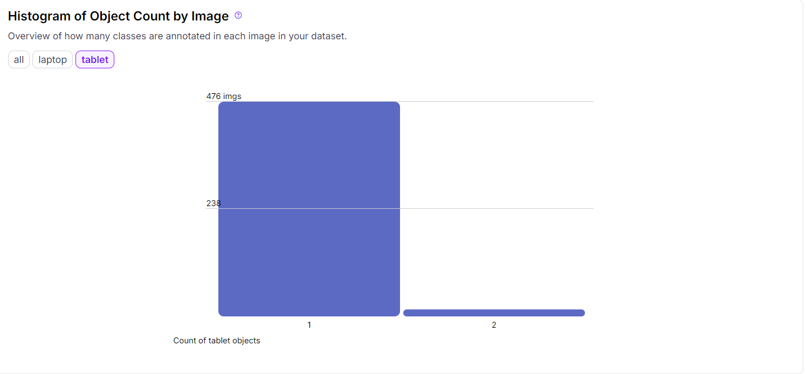

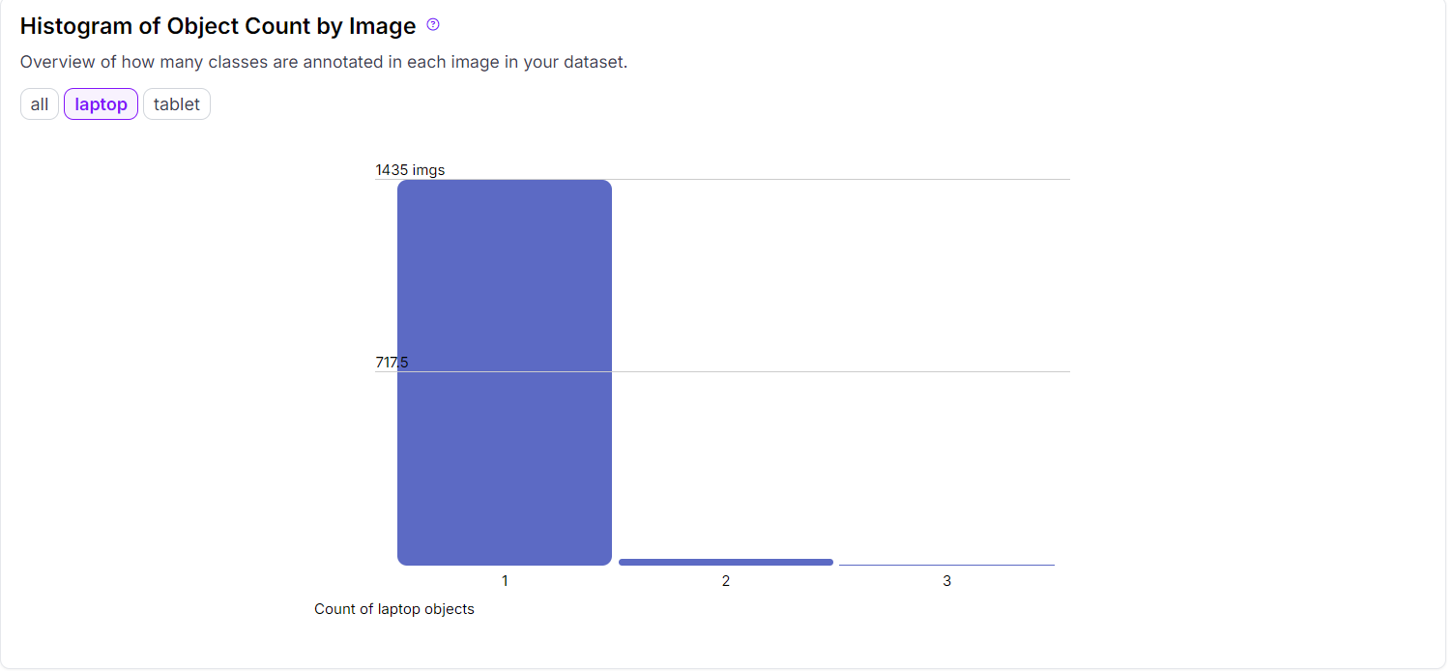

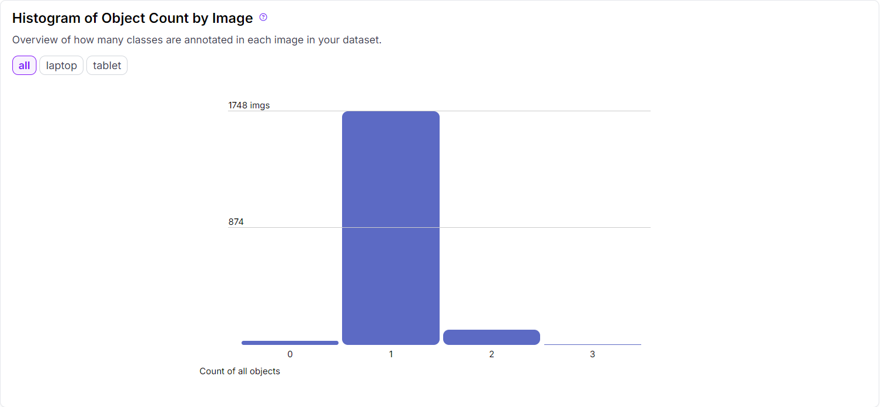

Although this much data is enough to realize my project, it is not enough to achieve a good result. That's why I performed certain augmentation operations to diversify and increase our data.

For augmentation operations I performed the following: Flip, 90 degree rotation, shear. So I almost tripled the data.

After researching image processing models, I decided to use Yolo models. Especially for high accuracy values, I aim to achieve more successful results with Yolo models. For this purpose, I started to research Yolo models Yolo5, Yolo8, Yolo9. The reason why I focused only on these three models is that these models are the most successful models among Yolo models.

I started comparing a small dataset to choose between the models and below I have attached the results of my comparisons and explained the final result.

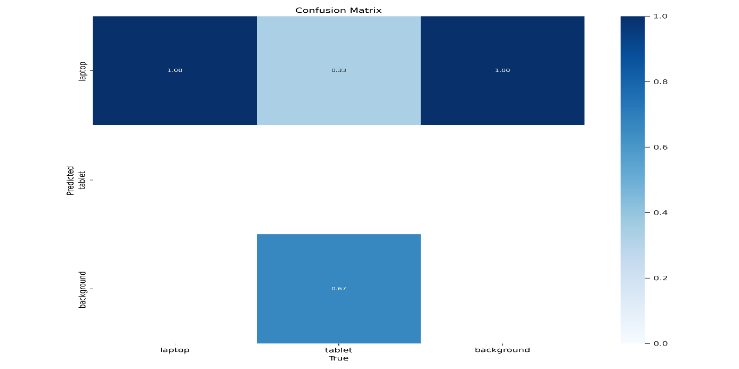

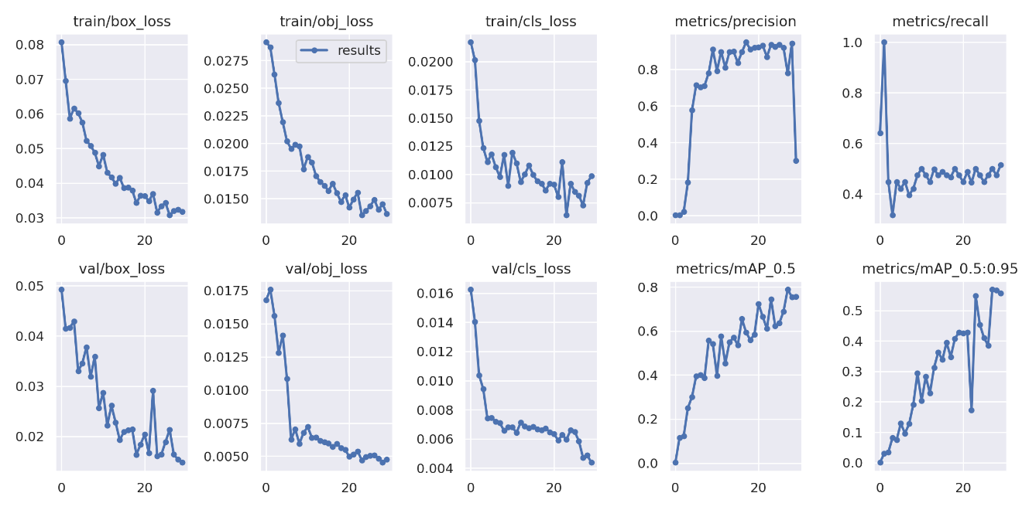**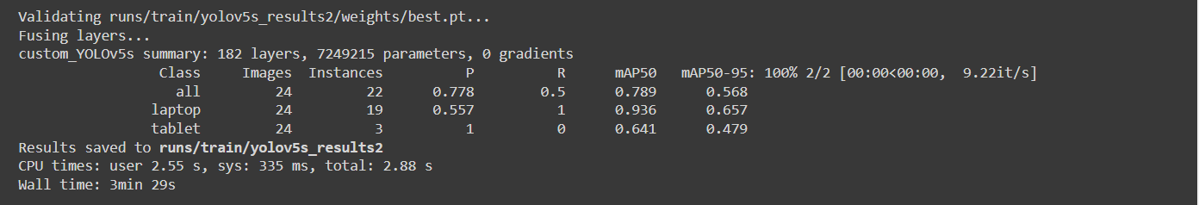YOLO5:**

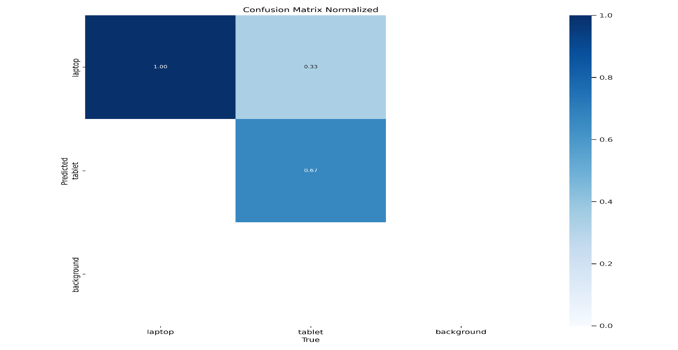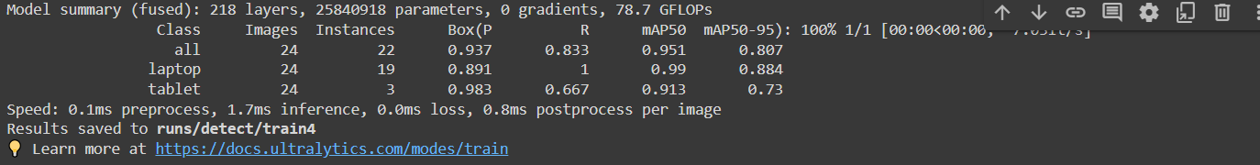**YOLO8:**

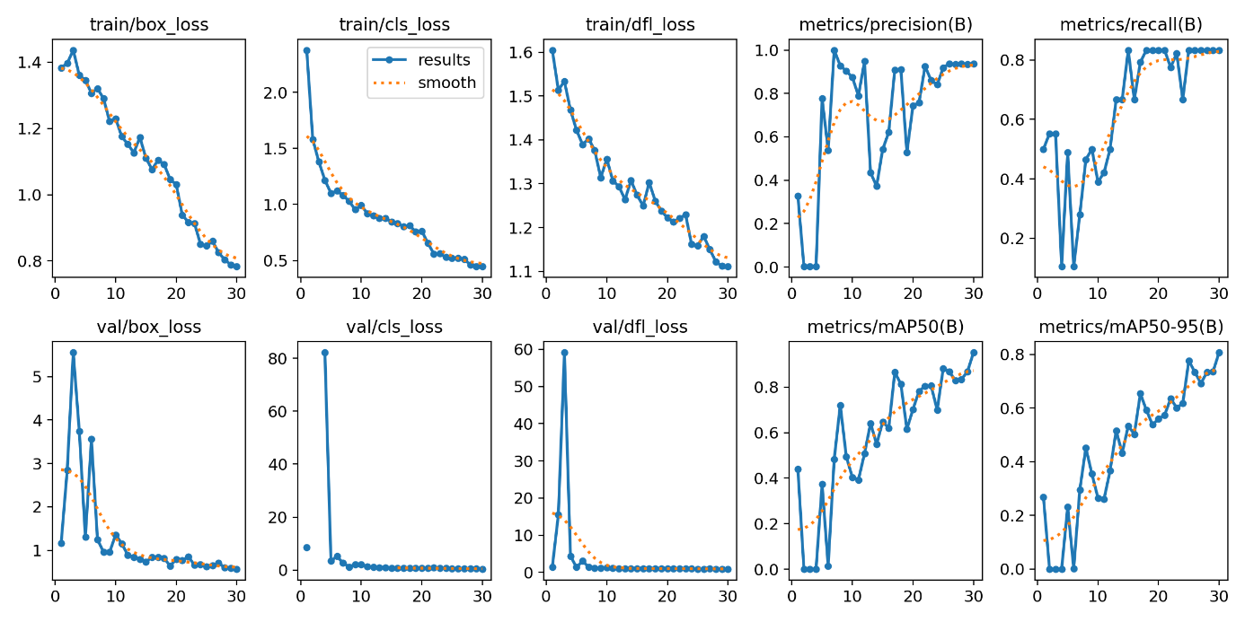

**YOLO9:**

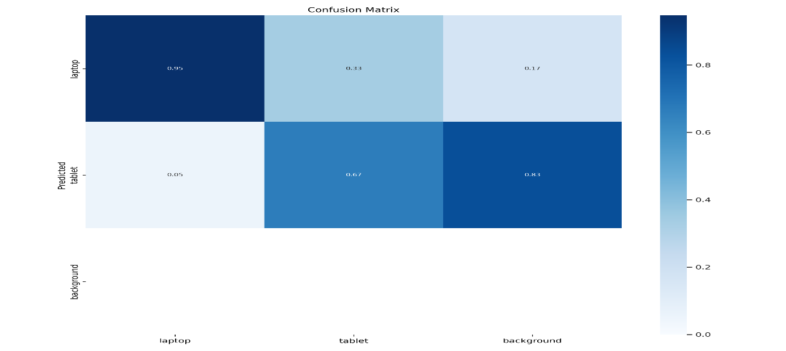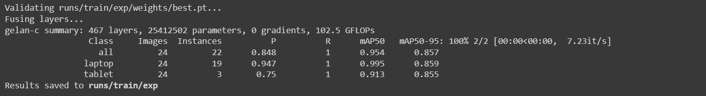

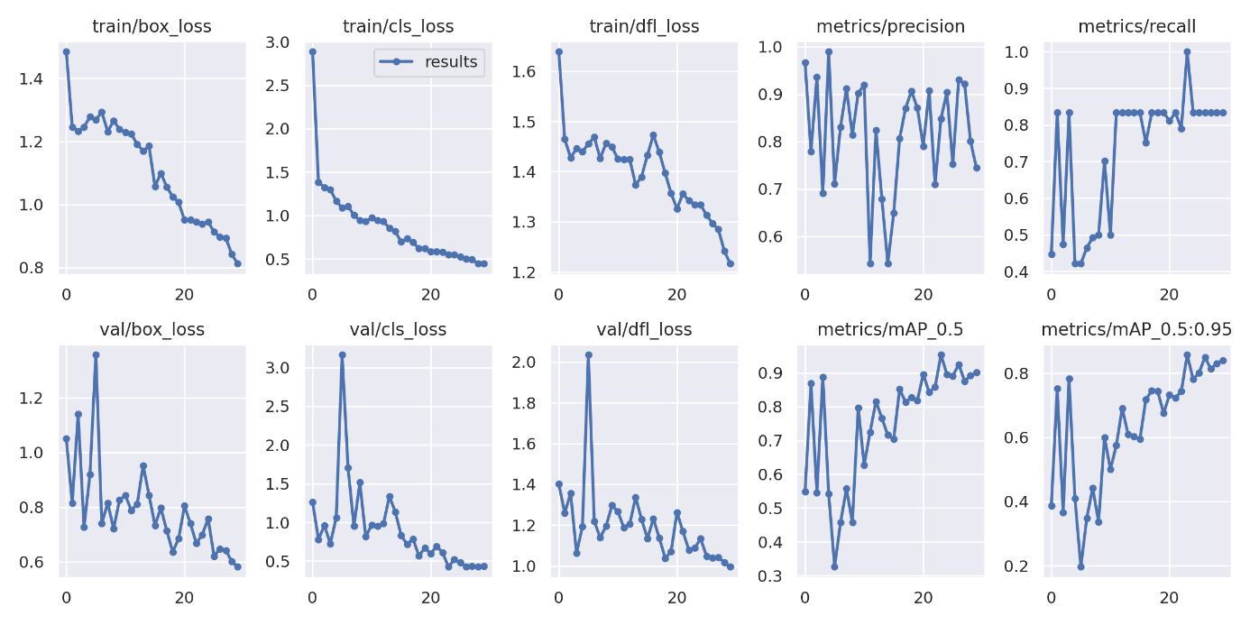

I also share the tabulated results of the 3 models below.

|  |  |  |  |  |  |  |
| --- | --- | --- | --- | --- | --- | --- |
| Model | Class | Images | Instances | P | mAP50 | mAP50-95 |
| YOLOv9_416 | All | 24 | 22 | 0.781 | 0.951 | 0.851 |
|  | Laptop | 24 | 19 | 0.82 | 0.99 | 0.847 |
|  | Tablet | 24 | 3 | 0.743 | 0.913 | 0.856 |
| YOLOv9_640 | All | 24 | 22 | 0.848 | 0.954 | 0.857 |
|  | Laptop | 24 | 19 | 0.947 | 0.995 | 0.859 |
|  | Tablet | 24 | 3 | 0.75 | 0.913 | 0.855 |
| YOLOv9_920 | All | 24 | 22 | 0.925 | 0.92 | 0.864 |
|  | Laptop | 24 | 19 | 0.947 | 0.977 | 0.884 |
|  | Tablet | 24 | 3 | 0.667 | 0.863 | 0.844 |

In the results I obtained, the Yolo9 model was the most successful model for me. You can see it in the table, especially in mAP50 results.

I decided to use the Yolo9 model in all these researches and comparisons. But then I made 3 more comparisons for 416, 640, 920 by changing the image sizes in the Yolo9 model.

I share the results below.

|  |  |  |  |  |  |  |
| --- | --- | --- | --- | --- | --- | --- |
| Model | Class | Images | Instances | P | mAP50 | mAP50-95 |
| YOLOv9_416 | All | 24 | 22 | 0.781 | 0.951 | 0.851 |
|  | Laptop | 24 | 19 | 0.82 | 0.99 | 0.847 |
|  | Tablet | 24 | 3 | 0.743 | 0.913 | 0.856 |
| YOLOv9_640 | All | 24 | 22 | 0.848 | 0.954 | 0.857 |
|  | Laptop | 24 | 19 | 0.947 | 0.995 | 0.859 |
|  | Tablet | 24 | 3 | 0.75 | 0.913 | 0.855 |
| YOLOv9_920 | All | 24 | 22 | 0.925 | 0.92 | 0.864 |
|  | Laptop | 24 | 19 | 0.947 | 0.977 | 0.884 |
|  | Tablet | 24 | 3 | 0.667 | 0.863 | 0.844 |

Here we can see that the size that gives us the best result is 640. As a result, I used the Yolo9 model and the 640 image size.

I used for my code batch, epochs and I shared the size code below.

!python /content/yolov9/train.py \

    --batch 16 --epochs 100 --img 640 --device 0 --min-items 0 --close-mosaic 15 \

    --data /content/datasets/X-ray-24/data.yaml \

    --weights /content/weights/gelan-c.pt \

    --cfg /content/yolov9/models/detect/gelan-c.yaml \

    --hyp hyp.scratch-high.yaml

**Some Results:**

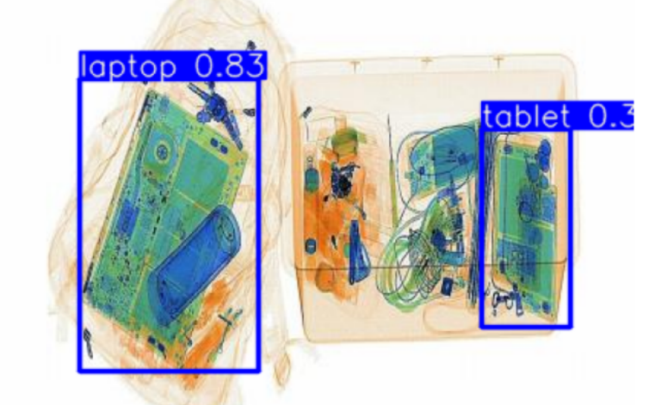

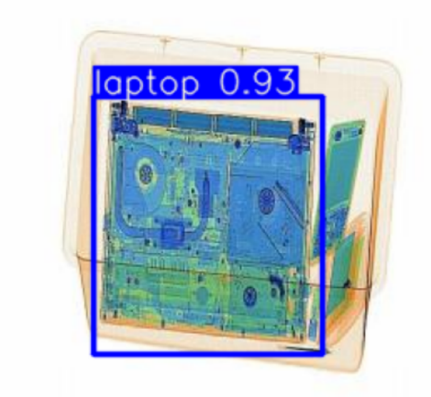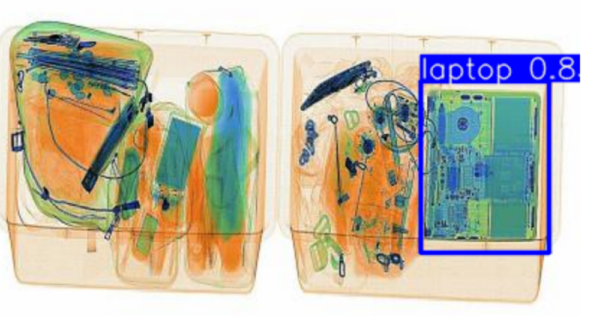

**Project 2: Website**

I developed a website for my image processing Project.

I used next.js for my website, I used mongodb for the database. I used figma for my frontend design.

Tablets or laptops passing through the Xray device will be detected and a match will be made with the IDs read on the devices, resulting in rejection, approval or warning.

I share the website below.

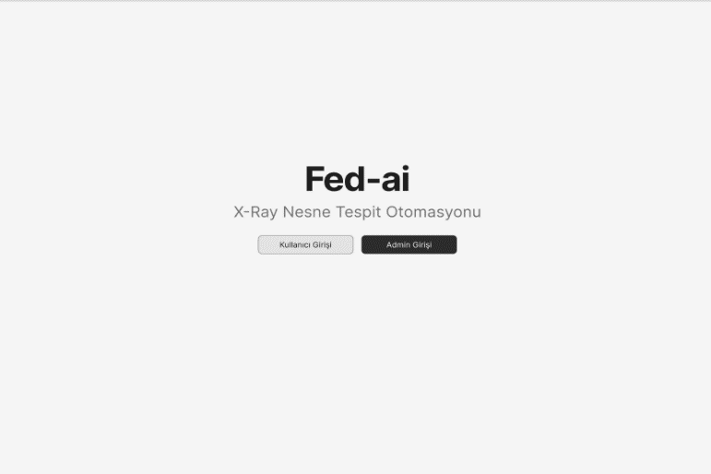**MAİN PAGE LOGIN**

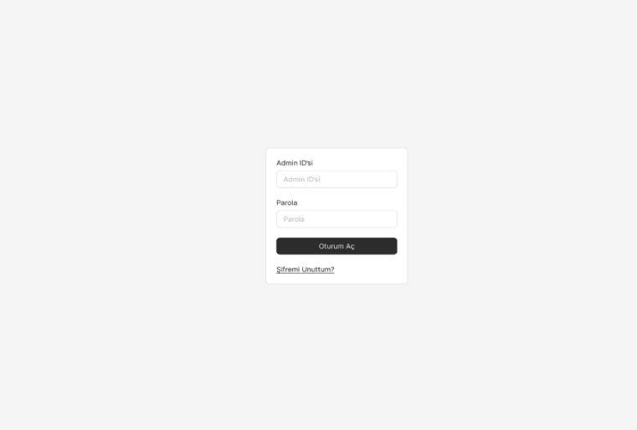

**HOME PAGE ADMIN LOGIN**

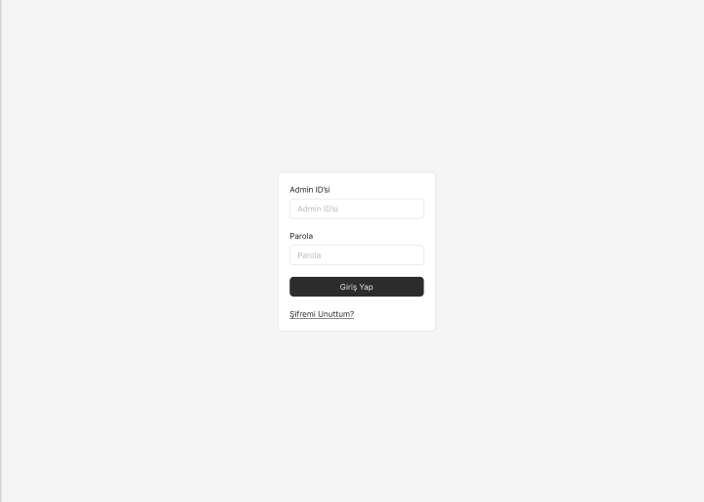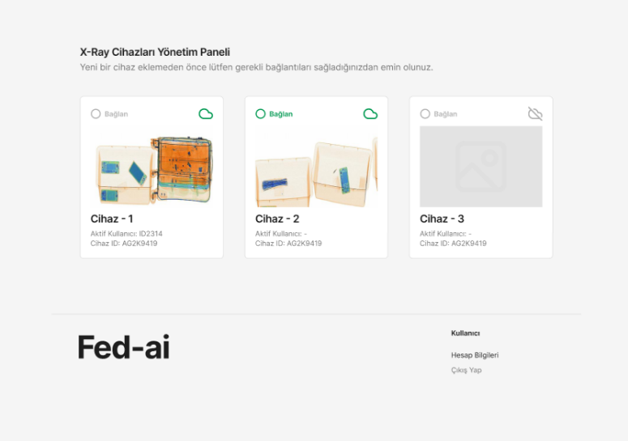

**ADMIN HOME PAGE APPROVAL PAGE**

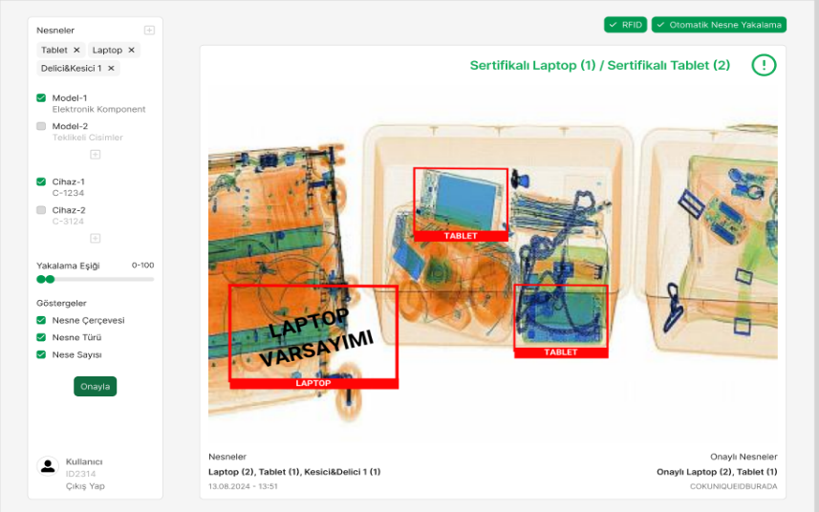

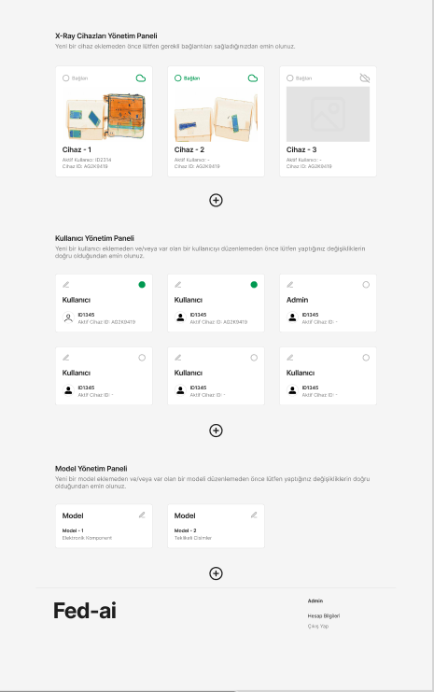**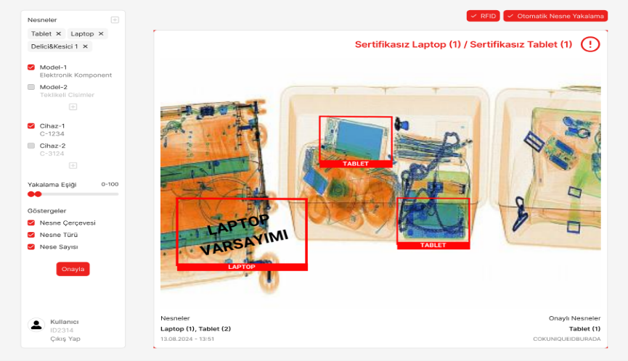REJECTION PAGE**

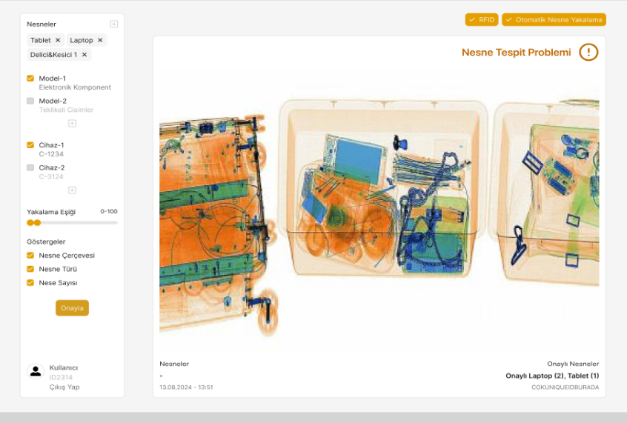**WARNING PAGE**

Laptops or tablets that pass through the X-ray machine have a recorded ID on them. Unregistered IDs cannot be removed or brought in. Therefore, when any device comes from our image, we check if there is any information from the ID. If there is any incoming ID, it gives approval, if there is no ID, the unregistered device passes and rejects it. In addition, if there is a possible ID but the device is not detected, it gives a warning.